单级感应线圈炮能量转换效率研究
张 三^{1a}，李 四²，赵大伟^{1b}，刘小虎^{1c}
（1．海军航空工程学院 a．院务部；b．新装备培训中心；
c．七系，山东 烟台 264001；2．海军装备部，北京 100071）
摘 要：在单级感应线圈炮的发射过程中，随着电容器组放电电压、电容量以及电枢初始位置的变化，弹丸出口速度和系统能量转换效率也将随之发生变化。为获得其中的规律，建立了单级感应线圈炮的数学模型，仿真分析了电容器组放电电压、电容量以及电枢初始位置对弹丸出口速度及系统能量转换效率的影响。分析结果表明，随着放电电压增加弹丸出口速度几乎呈直线上升，而系统能量转换效率却先增加后减小，存在一个最佳放电电压使得系统能量转换效率最大；随着电容器组电容量增加，弹丸出口速度不断增大但增幅逐渐减小趋于饱和，而系统能量转换效率先增加后减小，存在一个最佳电容器组电容量使得系统能量转换效率最大；随着电枢初始位置沿弹丸发射方向移动，弹丸出口速度和系统能量转换效率都先增大后减小，存在一个最佳初始位置使得二者同时达到最大。
关键词：单级感应线圈炮；电枢；能量转换效率

中图分类号：O441.3
文献标志码：A

0 引言
要实现感应线圈炮的工程应用，如何提高其系统能量转换效率将是一个必须解决的问题。以美国为首的欧美发达国家正在致力于该问题的研究。美国桑迪亚国家实验室正在研制应用于未来战斗系统(Future Combat Systems，FCS)上的感应线圈迫击炮，其能量转换效率可达22%^{[1-7]}。国内研制的感应线圈炮发射装置能量转换效率相对较低，一般在5%以内^{[8-10]}。而感应线圈炮的理论能量转换效率最高可达100%^{[11]}。由此，可以得出两个结论：一是无论国内还是国外的感应线圈炮能量转换效率都还有较大的提升空间；二是在感应线圈炮的能量转换效率上国内与国外相比存在一定的差距。文献[12]分析了单级线圈加速电枢的机理，并且进行了单级线圈加速的实验研究。文献[13]分析了电枢初始位置对弹丸速度的影响，仿真求解了系统的最佳初始位置。文献[14]对单级感应线圈炮的工作过程进行了仿真，并计算了系统的能量转换效率。但总的来说，国内对单级感应线圈炮能量转换效率的研究较少。

1 系统工作原理及数学模型

1.1 工作原理
感应线圈炮早期被称为“同轴发射器”，“质量驱动器”，或者“行波加速器”等，其原理是用脉冲或者交变电流产生磁行波来驱动带线圈的弹丸或者磁性材料弹丸^{[11,15]}。单级感应线圈炮是线圈炮的一个分支，一般由储能电源(如电容器组)、驱动线圈、发射组件(包括电枢和弹丸)以及触发控制开关等组成，基本结构见图1。
图1 单级感应线圈炮结构原理图
Fig.1 Fused image of the source images

1.2 数学模型
1.2.1 电路方程
在单级感应线圈炮的发射过程中，对于圆筒形的铝电枢，感应电流沿轴向的分布是不均匀的。因此，把电枢进行离散，沿轴向均分为m片，每片为一圆环，认为其环向电流沿截面均匀分布^{[16]}。经过上述处理，单级感应线圈炮的系统等效电路如图2所示。
图2 系统等效电路
Fig.2 System equivalent circuit
图2中：C为电容器组电容量；R为回路固有电阻，包括电容器组电阻、放电开关电阻和接线电阻；L为回路固有电感，包括电容器电感、放电开关电感和接线电感；R₀、L₀分别为驱动线圈的电阻和电感；和$L_{1},L_{2},⋯,L_{m}$分别为电枢分片的电阻和电感；$M_{\text{01}},M_{\text{02}},⋯,M_{0m}$为驱动线圈和电枢分片之间互感；$M_{\text{ij}}(i=1,2,⋯,m,j=1,2,⋯m,i≠j)$为电枢第i片和第j片之间的互感；U₀是电容器组充电电压。
在某一t时刻时，a和b之间的电路断开，此时。
对系统等效电路可建立如下方程：
(1)
(2)
(3)
$$⋮$$
(4)
单级感应线圈炮的结构参数见表1。

表1 RMSE平均比较
Tab.1 Comparison of RMSE average value
算法 | X轴位置平均RMSE(m) | Y轴位置平均RMSE(m) | X轴速度平均RMSE(m/s) | Y轴速度平均RMSE(m/s)
S-IMM5 | 12.4938 | 14.0908 | 2.3273 | 2.7796
SD-VSMM | 10.0366 | 8.9900 | 3.0303 | 2.9274
SA-VSMM | 8.7902 | 11.2237 | 3.1351 | 3.7196
SCD-VSMM | 6.1403 | 6.2550 | 3.9425 | 3.9223

在仿真过程中，将电枢沿轴向均分为10片，每一片都可以看作是一个单匝空心圆柱线圈。驱动线圈采用扁平铜带密绕，绕制线圈的铜带横截面积为0.5×10(矩形截面，单位mm²)，线圈匝数为33。弹丸的质量为1.285 kg。电枢的初始位置用驱动线圈和电枢的中心距s来度量，如图3所示。
图3 系统剖面图及结构参数
Fig.3 Fused image of the source images

2.2 电容器组电容量对弹丸出口速度及能量转换效率影响
给定放电电压为4 kV，放电时电枢和驱动线圈的中心距为20 mm，取电容器组电容量在[0, 10 000](单位μF)中变化，仿真得出的弹丸出口速度和能量转换效率随电容器组电容量变化的曲线如图6和图7所示。

3 结束语
本文建立了单级感应线圈炮的数学模型，仿真分析了电容器组放电电压、电容量以及电枢初始位置对弹丸出口速度及系统能量转换效率的影响，获得了放电电压、电容容量以及电枢初始位置与弹丸出口速度及系统能量转换效率之间的规律。
在单级感应线圈炮的发射过程中，通过增加电容器组放电电压、电容量以及寻找电枢最佳初始位置都可以提高弹丸出口速度。但是要提高能量转换效率必须对系统进行优化，通过配置最佳的电容器组放电电压、电容量以及电枢初始位置才能实现。

参考文献：
[1] Carter G C. Time delay estimation for passive sonar signal processing [J]. IEEE Transactions on Acoustics, Speech, Signal Processing, 1981, 29(3): 462-470.
[2] Stoica P, Li J. Lecture notes-source localization from range difference measurements [J]. IEEE Signal processing Magazine, 2006, 23: 63-66.
[3] Ge S S, Zhao Z, He W, Choo Y S. Localization of Drag Anchor in Mooring Systems Via Magnetic Induction and Acoustic Wireless Communication Network [J]. IEEE Journal of Oceanic Engineering, 2014, 39(3): 515-525.
[4] Chan Y T, Ho K C. A simple and efficient estimator for hyperbolic location [J]. IEEE Transactions Signal Processing, 1994, 42(8): 1905-1915.
[5] Beck A, Stoica P, Li J. Exact and Approximate Solutions of Source Localization Problems [J]. IEEE Transactions on Signal Processing, 2008, 56(5): 1770-1778.
[6] Lui K, Chan F, So H C. Semidefinite programming approach for range-difference based source localization [J]. IEEE Transactions on Signal Processing, 2009, 57(4): 1630-1633.
[7] Yang L, Ho K C. An approximately efficient TDOA localization algorithm in closed-form for locating multiple disjoint sources with erroneous sensor positions [J]. IEEE Transactions on Signal Processing, 2009, 57(12): 4598-4615.
[8] Sun M, Ho K C. An asymptotically efficient estimator for TDOA and FDOA positioning of multiple disjoint sources in the presence of sensor location uncertainties [J]. IEEE Transactions on Signal Processing, 2011, 59(7): 3434-3440.
[9] Luo Z Q, Ma W K, So A M, Ye Y Y, Zhang S Z. Semidefinite relaxation of quadratic optimization problems [J]. IEEE Signal Processing Magazine, 2010, 27(3): 20-34.
[10]Luo Z Q, Ma W K, So A M, Ye Y Y, Zhang S Z. Semidefinite relaxation of quadratic optimization problems [J]. IEEE Signal Processing Magazine, 2010, 27(3): 20-34.
[11] Gostar A, Hoseinnezhad R, Bab-Hadiashar A, Liu Weifeng. Sensor-management for multitarget filters via minimization of posterior dispersion[J]. IEEE Transactions on Aerospace & Electronic Systems, 2017, 53(6): 2877-2884.
[12] Hoang H, Vo B. Sensor management for multi-target tracking via multi-Bernoulli filtering[J]. Automatica, 2014, 50(4): 1135-1142.
[13] 陈辉, 贺忠良, 连峰, 李晨. 多目标跟踪中基于目标威胁度评估的传感器控制方法[J]. 电子与信息学报, 2018, 40(12): 2861-2867.

作者简介：
相片宽度为1.8cm， | XXX(1987-)，男，讲师，博士学历，研究方向：雷达数据处理、组网融合、情报体系评估等。  Email: xxx@126.com

Research of Energy Conversion Efficiency
in Single Stage Induction Coilgun
XIN Qing-wei^{1a}，CAO Wan-ping²，SHANG Chong-wei^{1b}，LIU Wen-biao^{1c}
（Naval Aeronautical and Astronautical University a. Department of General Affairs；
b. New Equipment Training Center；c. Graduate Students’ Brigade，Yantai Shangdong 264001，China；
2．Naval Equipment Department，Beijing 100071，China）
Abstracts: During the launch of single stage induction coilgun, the change of the initial position of the armature, the discharge voltage and the capacitance of capacitors will affect the electrical-to-kinetic energy conversion efficiency of the system. In order to gain the rule between them, the mathematic model of single stage induction coilguns was built, and the influence of the initial position of armature, the discharge voltage and the capacitance of capacitors on the muzzle velocity of projectile and the electrical-to-kinetic energy conversion efficiency of the system was simulated and analyzed. Results of investigation showed that the muzzle velocity of projectile almost linearly increased with the discharge voltage of capacitors increasing. However, the energy conversion efficiency increased at first and decreased later with the discharge voltage of capacitors increasing. There was a best discharge voltage with which the maximum energy conversion efficiency was obtained. With the capacitance of capacitors increasing, the muzzle velocity of projectile gradually increased and leveled off at last. While the energy conversion efficiency also increased at first and decreased later with the capacitance of capacitors increasing. There was a best capacitance which could maximize the energy conversion efficiency. With the initial position of the armature moving towards the launch direction of projectile, the muzzle velocity of projectile and the energy conversion efficiency both increased at first and decreased later. There was a best initial position of the armature which could maximize the muzzle velocity of projectile and the energy conversion efficiency at the same time.
Key words: single stage induction coilgun; armature; energy conversion efficiency

0 Introduction
Visual tracking is one of the basic research topics in the field of computer vision. It has a wide range of applications in video surveillance, robotic vision, human-computer interaction and driverless vehicles. To improve the weakness of scale-invariant template used in the original correlation filter tracking method, we propose an adaptive scale correlation filtering feature tracker based on context awareness and integration(FCSCF). To improve the speed of our algorithm, we employ an adaptive dimension reduction technology. Finally, context-aware model is applied to FCSCF.

1 THE TRACKER

1.1 CF Tracking
Before discussing the details of our proposed framework, let us first give a brief overview of traditional CF tracking. CF tracker uses discriminatory learning in its core. The key factor to the success of CF tracker is its sampling method. The equation of is: . The cyclic structure of the matrix is helpful to solve the following ridge regression problems in the frequency domain.
(1)
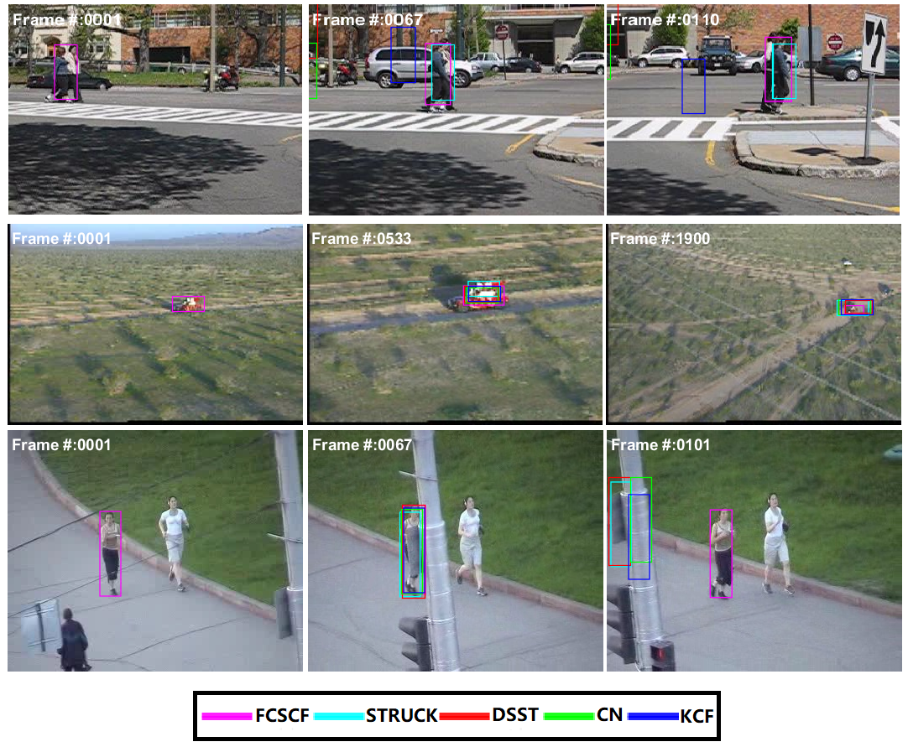
Fig.2 Compare our method with the most advanced trackers in challenging situations, such as lighting changes, occlusion, deformation and in plane rotation. The sample frameworks are from Couple, Red Team and Jogging1 sequences, respectively.

REFERENCES：
[1] Carter G C. Time delay estimation for passive sonar signal processing [J]. IEEE Transactions on Acoustics, Speech, Signal Processing, 1981, 29(3): 462-470.
[2] Stoica P, Li J. Lecture notes-source localization from range difference measurements [J]. IEEE Signal processing Magazine, 2006, 23: 63-66.

Author's Brief Introduction
相片宽度为1.8cm | XXX(1987-)，Male, Master of Automation College of Southeast University, Research Direction: Target Tracking.  Email: xxx@126.com

附件：
参考文献严格按国标文后参考文献录著标准录著，顺序编码法标注（从引言到结语中按照引文出现的先后顺序依次编码），应选最必要、最新的文献，数量不少于10篇，中文文献应提供对应的英文信息。如：
（1）专著：[序号]著者. 书名[M]. 版本（第一版部著录）.译者. 出版地：出版者，出版年：起止页码.
（2）期刊：[序号]作者. 题名[J]. 刊名，年，卷（期）：起止页码.
（3）会议论文集：[序号]作者. 题名[C]//文集名. 出版地：出版者，出版年：起止页码.
（4）学位论文：[序号]作者. 题名[D]. 保存地点：保存单位，年份.
（5）专利文献：[序号]专利申请者. 专利题名：专利国别，专利号[P]. 出版日期.
（6）报纸：[序号]作者. 题名[N]. 报纸名，年-月-日（版次）.
（7）技术标准：[序号]标准名称：标准代号标准顺序号-发布年[S]. 出版地：出版者，出版年.
（8）科技报告：作者. 题名：报告编号[R]. 出版地：出版者，出版年.
（9）电子文献的著录格式：[序号]主要责任者. 题名[文献类型/载体标志]. （更新或修改日期）[引用日期]. 电子文献的出处或可获得的地址. 其中：文献类型标志为M、C、D、R、J、S、P、DB（数据库）、CP（计算机程序）、EB（电子公告）；载体类型标志为MT（磁带）、OK（磁盘）、CD（光盘）、OL（联机网络）。

