附件2：论文摘要模版

TITLE – INEF2016 Abstract Template
Lotta Sartz^{1,2}, Mattias Bäckström²
¹Bergskraft Bergslagen AB, Fordonsgatan 4, 692 71 Kumla, Sweden
²Man-Technology-Environment Research Centre, Örebro University, 701 82 Örebro, Sweden
email: lotta.sartz@oru.se, mattias.backstrom@oru.se

Please write your abstract using this template. Maximum number of words around 500 (maximum 1 page). One table or figure might fit if deemed necessary.
XXXXXXXXXXXXXXXXXXXXXXXXXXXXXXXXXXXXXXXXXXXXXXXXXXXXXXXXXXXXXXXXXXXXXXXXXXXXXXXXXXXXXXXXXXXXXXXXXXXXXXXXXXXXXXXXXXXXXXXXXXXXXXXXXXXXXXXXXXXXXXXXXXXXXXXXXXXXXXXXXXXXXXXXXXXXXXXXXXXX

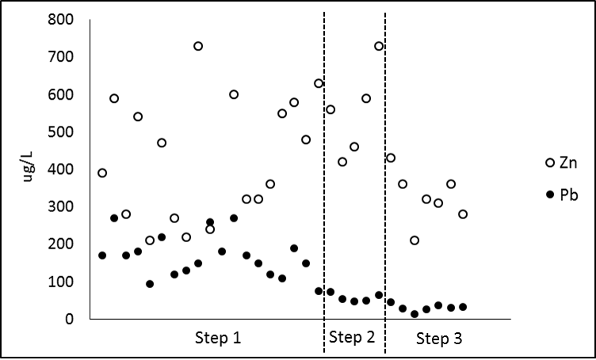
Figure 1: Use Arial font for figures.

XXXXXXXXXXXXXXXXXXXXXXXXXXXXXXXXXXXXXXXXXXXXXXXXXXXXXXXXXXXXXXXXXXXXXXXXXXXXXXXXXXXXXXXXXXXXXXXXXXXXXXXXXXXXXXXXXXXXXXXXXXXXXXXXXXXXXXXXXXXXXXXXXXXXXXXXXXXXXXXXXXXXXXXXXXXXXXXXXXX

Key words:
Please provide a couple of relevant key words for every abstract.

References:
[1] Bäckström, M. and Sartz, L. (2016) Title of paper. Journal Title, Volume, Issue, XX-XX

