ISO/NP 19609-3 Traditional Chinese Medicine -- Quality and Safety of natural materials and manufacturing products made with natural materials – Part 3: Testing of the absence of contaminants

Contents

Foreword
Introduction
1 Scope
2 Normative references
3 Terms and definitions
4 Testing of the absence of contaminants
4.1 General
4.2 Microorganisms
4.2.1 Testing method
4.2.2 Limits
4.3 products from microorganisms
4.3.1 Testing method for aflatoxins
4.3.2 Limits
4.4 Heavy metals (arsenic, cadmium, lead, mercury)
4.4.1 Testing methods
4.4.1.1 AAS (atom absorption spectrometry)
4.4.1.2 ICP (inductively coupled plasma spectrometry) / ICP-MS
4.4.1.3 Other methods
4.4.2 Limits
4.5 Pesticides
4.5.1 Testing methods
4.5.1.1 GC/MS (Gas chromatography coupled with mass spectrometry)
4.5.1.2 LC/MS (Liquid chromatography coupled with mass spectrometry)
4.5.2 Definiton of relevant pesticides
4.5.2.1 national regulations
4.5.3 Limits
Foreword

Introduction

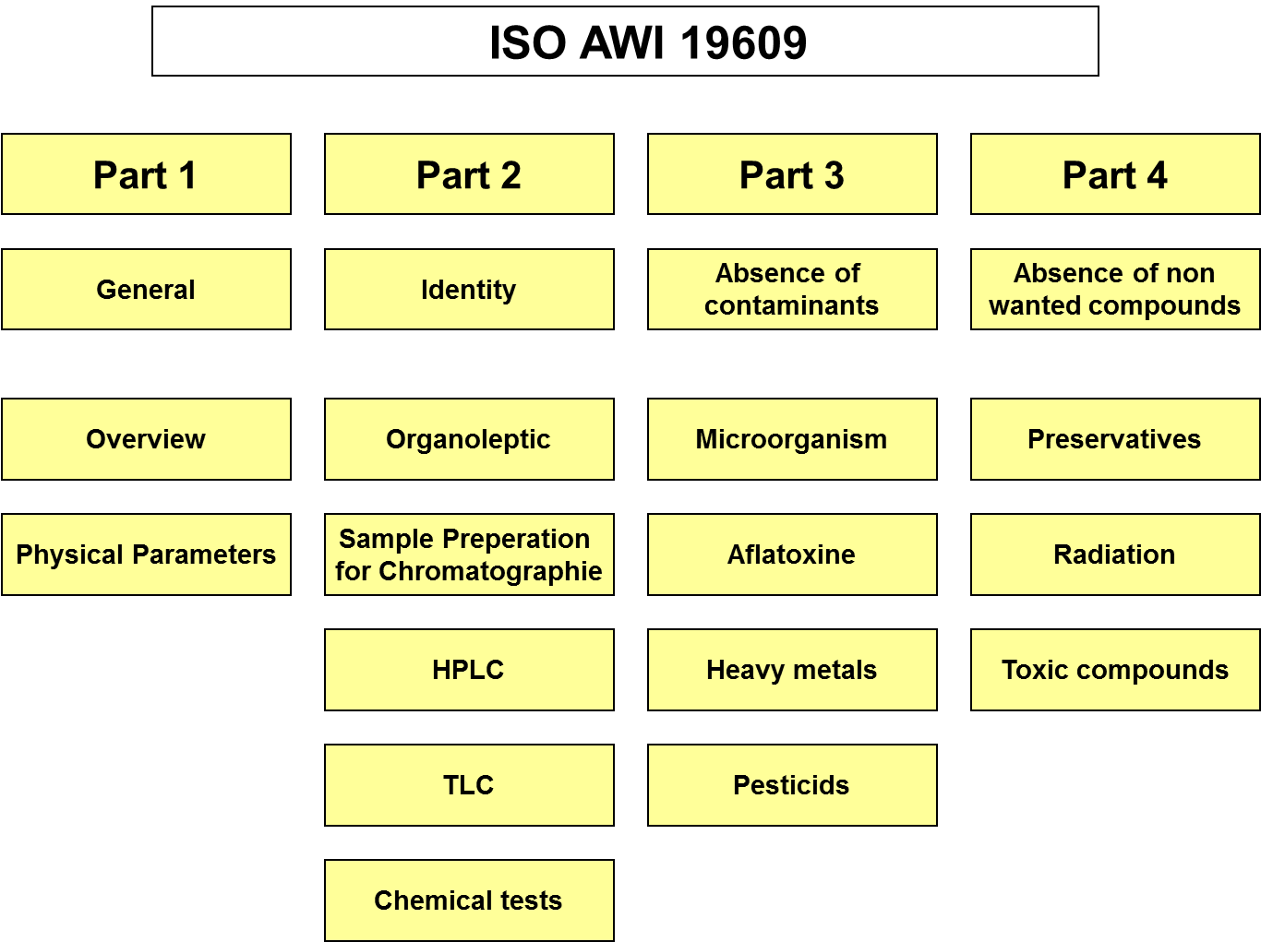

1 Scope

This standard applies to the testing of the absence of contaminants within a quality control framework for starting materials and finished products, used in and as traditional Chinese medicine (TCM), and the comparison between the starting materials and the finished products if necessary. Starting materials are any incoming materials to be commercially processed, manufactured or packaged. Finished products are commercial products intended for sale and use, including decoction pieces.

2 Normative references

3 Terms and definitions

See ISO 19609-1

xxx

4 Testing of the absence of contaminants
4.1 General

The absence of contaminants shall be proved in five different cases:
- Microorganism (see 8.2)
- products from microorganisms (see 8.3)
- Heavy metals (arsenic, cadmium, lead, mercury)(see 8.4)
- Pesticides (see 8.5)

4.2 Microorganisms
4.2.1 Testing method

For testing of Microorganism the method of culture plate tests shall be used.

For the procedure see European Pharmacopoeia, 5.1.4. (Annex I)

4.2.2 Limits

The limits for the absence of microorganism are specified in the European Pharmacopoeia, 5.1.4. or other national regulations
The test results shall comply with these limits taking into account national legislation.

4.3 products from microorganisms
4.3.1 Testing method for aflatoxins

HPLC quantification method
For the procedure see European Pharmacopoeia 2.8.18 (Annex J)

4.3.2 Limits

The limits for the absence of products from microorganisms are specified in the European Pharmacopoeia 2.8.18 or other national regulations

The test results shall comply with these limits taking into account national legislation.

4.4 Heavy metals (arsenic, cadmium, lead, mercury)
4.4.1 Testing methods

For the procedure see European Pharmacopoeia 2.4.8 (Annex K)

4.4.1.1 AAS (atom absorption spectrometry)

For the procedure see European Pharmacopoeia 2.4.27 (Annex L)

4.4.1.2 ICP (inductively coupled plasma spectrometry) / ICP-MS

4.4.1.3 Other methods

4.4.2 Limits
The limits for the content of heavy metals are specified in the European Pharmacopoeia 2.4.8. or other national regulations

4.5 Pesticides
4.5.1 Testing methods
4.5.1.1 GC/MS (Gas chromatography coupled with mass spectrometry)

For the procedure see European Pharmacopoeia 2.8.13 (Annex M)

4.5.1.2 LC/MS (Liquid chromatography coupled with mass spectrometry)

4.5.2 Definiton of relevant pesticides
4.5.2.1 national regulations

For the definition of minimum relevant pesticides see European Pharmacopoeia 2.8.13 and the EU directives 76/895 (Annex N) and 90/642 (Annex O) or other national requirements
8.5.2.2 declaration of producer

4.5.3 Limits

European Pharmacopeia 2.8.13 or national regulations

